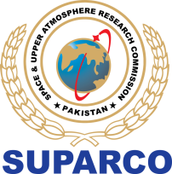

WORLD SPACE WEEK -24
PUBLIC CONTESTS

POST EVENT REPORT

PUBLIC CONTEST: SPACE FOR CLIMATE- VIDEO CHALLENGE

PARTICIPANT  DETAILS | Name:
PARTICIPANT  DETAILS | Address:
PARTICIPANT  DETAILS | City: | District: | Province
PARTICIPANT  DETAILS | Landline: | Mobile No: | Email ID:

SUBMISSION DETAILS
 | VIDEO TITLE
2. | THEME FOCUS  (EXPLAIN THE CONNECTION BETWEEN SPACE TECHNOLOGY AND CLIMATE ACTION)
3. | PUBLIC ENGAGEMENT  (HOW CAN THE PUBLIC CONTRIBUTE?)
VIDEO/PICTURES LINK
(POST PUBLIC LINK OF THE PICTURES AND VIDEO)
Don’t forget to use the hashtags #WSW24Pakistan, #SEAD, #sSpaceforClimate with your pictures and video.

- Fill this form and submit via google link https://forms.gle/V3iS3zFD4ohzaG7ZA

