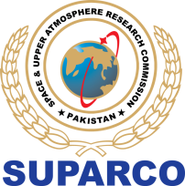
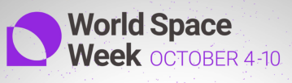
WORLD SPACE WEEK -24
PUBLIC CONTESTS

POST EVENT REPORT

PUBLIC CONTEST: TRIPLE R ACTION: REUSE, REDUCE & RECYCLE FOR CLIMATE ACTION

PARTICIPANT  DETAILS | Name:
PARTICIPANT  DETAILS | Address:
PARTICIPANT  DETAILS | City: | District: | Province
PARTICIPANT  DETAILS | Landline: | Mobile No: | Email ID:

SUBMISSION DETAILS
DETAILS OF SELECTED EVERYDAY ITEM
(PLASTIC BOTTLES, OLD CLOTHES ETC)
2. | CATEGORY FOCUS  (REUSE, REDUCE, RECYCLE)
3. | PROJECT DESCRIPTION  (DESCRIBE YOUR INNOVATIVE APPROACH TO REDUCING WASTE, REUSING ITEMS, OR RECYCLING)
VIDEO/PICTURES LINK
(POST PUBLIC LINK OF THE PICTURES AND VIDEO)
Don’t forget to use the hashtags #WSW24Pakistan, #SEAD, #TripleRAction with your pictures and video.

- Fill this form and submit via google link https://forms.gle/V3iS3zFD4ohzaG7ZA

